

Consultant Recruitment Notification
Proprietary and Confidential
ISG Confidential. © 2022 Information Services Group, Inc. All Rights Reserved.

Presented by:
Information Services Group, Inc.
2022. 07. 07

ISG (Information Services Group, Inc. NASDAQ(III)) 서울오피스에서 전략 수립, 프로세스 혁신 및 디지털 트랜스포메이션 관련 컨설턴트를 모집합니다.

1. 채용분야 및 인원
- 신입 컨설턴트 : 0 명
- 담당 업무 : Strategy, PI, Digital TransformationI 등 컨설팅 프로젝트 수행

- RA : 0 명
- 담당 업무 : 리서치 및 분석, 컨설팅 보고서 작성
- 프로젝트 후 평가를 통해 정규직 전환 가능

2. 지원자격
- 신입 컨설턴트
- 4년제 정규대학 졸업자 혹은 졸업 예정자
- 컨설팅 업무 경험자 우대

- RA
- 4년제 정규대학 졸업자 혹은 졸업 예정자
- 계약기간 : 투입되는 프로젝트 종료 시 까지 (2 ~ 3 개월)

3. 제출서류 (필수)
- 영문 이력서 및 영문 자기소개서

4. 제출 기한 및 지원 방법
- 제출 기한 : 2022년 7월 22일 (금)
- 지원자는 해당 서류를 이메일 recruiting@isg-one.co.kr로 제출
- 메일 제목은 ‘ISG Korea-OOO(이름) 입사지원서”로 표기
- 모든 제출 서류는 MS Word로 작성
※ 채용관련 문의사항은 e메일 recruiting@isg-one.co.kr로 해 주십시오.
※ ISG(www.isg-one.com)는 21개국 28개 Office를 통하여 기업의 경영 및 IT 컨설팅을 수행하는 Global Leading Management Consulting Firm입니다.

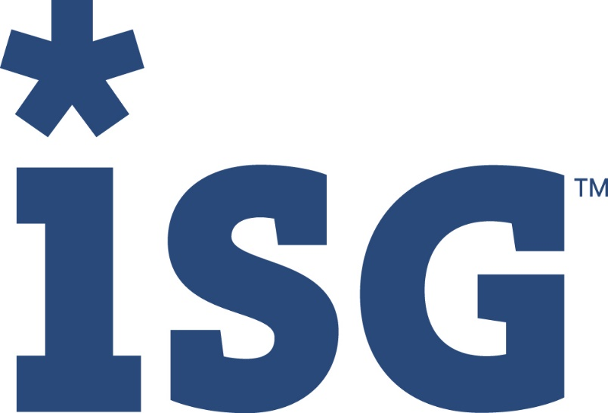
ISG (Information Services Group) (NASDAQ: III) is a leading global technology research and advisory firm. A trusted business partner to more than 700 clients, including 75 of the top 100 enterprises in the world, ISG is committed to helping corporations, public sector organizations, and service and technology providers achieve operational excellence and faster growth. The firm specializes in digital transformation services, including automation, cloud and data analytics; sourcing advisory; managed governance and risk services; network carrier services; technology strategy and operations design; change management; market intelligence and technology research and analysis. Founded in 2006, and based in Stamford, Conn., ISG employs more than 1,300 professionals operating in more than 20 countries—a global team known for its innovative thinking, market influence, deep industry and technology expertise, and world-class research and analytical capabilities based on the industry’s most comprehensive marketplace data.
ISG Confidential. © 2022 Information Services Group, Inc. All Rights Reserved.
Proprietary and Confidential. No part of this document may be reproduced in any form or by any electronic or mechanical means, including information storage and retrieval devices or systems, without prior written permission from Information Services Group, Inc.
isg-one.com
ISG (Information Services Group) (NASDAQ: III) is a leading global technology research and advisory firm. A trusted business partner to more than 700 clients, including 75 of the top 100 enterprises in the world, ISG is committed to helping corporations, public sector organizations, and service and technology providers achieve operational excellence and faster growth. The firm specializes in digital transformation services, including automation, cloud and data analytics; sourcing advisory; managed governance and risk services; network carrier services; technology strategy and operations design; change management; market intelligence and technology research and analysis. Founded in 2006, and based in Stamford, Conn., ISG employs more than 1,300 professionals operating in more than 20 countries—a global team known for its innovative thinking, market influence, deep industry and technology expertise, and world-class research and analytical capabilities based on the industry’s most comprehensive marketplace data.

