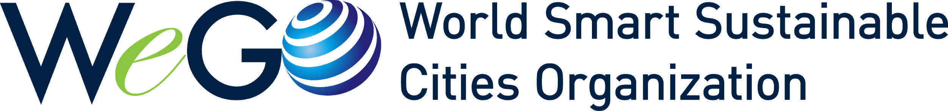

Job Opening for Program Officer

Application Deadline: June 26, 2022

The WeGO Secretariat is currently seeking candidates for the following vacancies:

- Program Officer: 1 Person

About WeGO

The World Smart Sustainable Cities Organization (WeGO), established by 50 founding member cities in 2010, is an international association of city and other local governments, smart tech solutions providers, and national and regional institutions committed to the transformation of cities into smart sustainable cities.

WeGO’s Secretariat is based in Seoul, Korea, with regional offices in East Asia (Chengdu, China), Eurasia (Ulyanovsk, Russia), the Mediterranean (Beyoğlu, Turkey), and Latin America (Mexico City, Mexico).

WeGO has 212 members around the world and serves as their international platform to improve the quality of life, innovate in the delivery of public services, and strengthen regional competitiveness.

Responsibilities:
- Identify and matchmake smart city projects among members
- Regional Office management and supporting
- Communicate with national and local governments to connect with cities, and access city and related networks for expanded recruitment.
- Organize and carry out activities such as conferences and expos, training programs, and others related to smart cities, for and with a range of local governments, corporations, and institutions.
- Work with international organizations and other partners to develop new strategic partnerships and carry out joint initiatives.
- Develop current and new products and services with a focus on the needs and interests of members and partner organizations.
- Support WeGO activities and the management and recruitment of members, establishing and implementing a sound strategy for membership expansion and fee payment.
* Tasks and responsibilities may change in accordance with the organization’s needs.

Qualifications:
REQUIRED
- Native/fluent English speaker
- Bachelor’s degree and at least two (2) years—or, master’s degree and at least one (1) year—of work experience at an administrative agency, an international organization/institution, enterprise, etc. (Internships are not counted toward this requirement)

- Strong skills in business writing, reporting, and presenting, and in conducting research
- Excellent computer skills (MS Office, Google Office Suite)
- Attention to detail, commitment, passion, and interest in smart cities
- No legal restrictions on overseas travel
- No legal restrictions to work in the Republic of Korea

OPTIONAL
- Fluency in Korean or Fench
- Work experience in international organizations or international cooperative tasks

Contract:
- Start date: August 2022
- Duty Station: WeGO Secretariat, 7F, Seoul Global Center, Jongno-gu, Seoul, South Korea
- Term: Two (2) years, incl. a three (3) month probationary period
- Hours: Monday to Friday, eight (8) hours per day
- Language: English
- Annual Leave: Twenty-six (26) days

*The contract term may be extended based on the results of an annual assessment(s) and the needs of the organization.
**The contract term may be terminated as a result of unsatisfactory assessment during the probationary period or upon annual assessment.

Benefits:
- National pension program (if applicable), medical and other applicable insurance
- Annual Salary: Around KRW 33,000,000

*The detailed annual salary will be determined under the terms of the employment contract and only 90% of the monthly salary will be paid during the probationary period

Required Documents:

- Application Form
- Resume and Cover Letter

Recruitment Procedures:

- Deadline for Submission of Required Documents – 26 June 2022
Please Note: Only applicants who pass the document assessment stage will be invited to participate in the next stage of the recruitment process.
- Second Round: English/Korea Written Test – 30 June 2022
Please Note: Only applicants who pass the Second Round will be invited to participate in the next stage of the recruitment process.
- Third Round: Interview – 5 July 2022
(either face to face or online for candidates overseas)
4. Announcement of Final Selection – 7 July 2022
* Recruitment schedule may change in accordance with the organization’s needs.

Application Procedure:

Please download the application form from WeGO’s website (www.we-gov.org/careers) and submit it along with all necessary documents to admin@we-gov.org with the subject “WeGO Job Opening – Program Officer” by the deadline.

For inquiries, please contact:
Administrative Director Hyunmi Lee (hyunlee@we-gov.org | 02-720-2933)

